**Leader Overview**

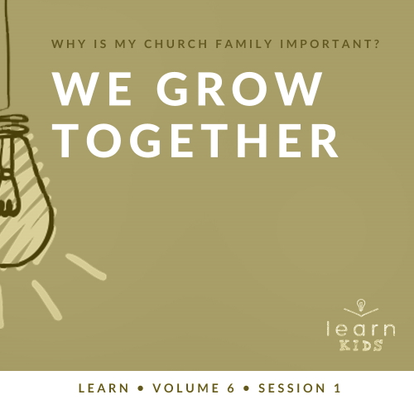

**Volume Overview**

**Why is my church family important?**

*When we think of church, it’s easy for our mind to be instantly drawn to the building where we attend. However, in God’s design, the church isn’t the building that we gather in. Instead, church has everything to do with the people who are gathered there. In essence, the biblical church is not a building that we go to but a family of believers that we belong to*.

*As our Father, God’s heart is to adopt us into His family (*[*Ephesians 1:5*](https://ref.ly/logosref/Bible.Eph1.5)*). When we choose to put our faith in Jesus, we instantly join God’s family. We not only belong to Him, but we also belong to each other. Just like our natural families here on earth were meant to function, God uses our church family to meet our needs. A healthy church family offers love, encouragement, guidance, and accountability. As the family of God—the Church—we grow together, celebrate together, share together, and even serve together. As we make a commitment to God’s family, we will become stronger, more devoted followers of Jesus*.

**Session Overview**

**We Grow Together**

*God wants His people to gather together and live in community. One of the reasons for this is so we can grow together as believers. The Early Church sacrificed much to follow Jesus. Many of them gave all their possessions and some were disowned by their families. We can learn from how they committed to grow together*.

**Bible Lesson**

Believers Grow Together

[Acts 2:42–47](https://ref.ly/logosref/Bible.Ac2.42-47); [Ephesians 5:17–20](https://ref.ly/logosref/Bible.Eph5.17-20)

**Faith Fact**

We grow together.

**Faith Verse**

[Matthew 18:20](https://ref.ly/logosref/Bible.Mt18.20) (NLT)

“For where two or three gather together as my followers, I am there among them.”

**Preparing for the Session**

**Leader Preparation Time: 20–25 Minutes**

|  |
| --- |
| ***You Will Need***  ***Large Group***   * *Bible* * *Worship songs (Song suggestions: “The Blessing” by Elevation Worship; “The Stand” by Hillsong United; “Broken Vessels” (Amazing Grace) by Hillsong Worship; “This Is a Move” by Bethel Music Worship)* * *For groups not using a phone or tablet only, add:*   *• Projector or TV*  *• Laptop*  *•* ***Countdown60 Video****–60 seconds*  *•* ***Faith Fact Slide***  *•* ***Faith Verse Video*** *or* ***Slide***  *•* ***Bible Lesson Video***  *•* ***Teaching Point Slides 1–3***   * *Potted plant with good roots (You must be able to pull the plant out of the pot and show the kids the roots.)* * *Plastic gloves* * *Disposable tablecloth* * *10–12 large blocks (enough to build a large tower quickly)* * *Small table* * *Basketball*   ***Small Group***   * *Large building blocks, forty blocks per group* * ***Countdown60 Video****–60 seconds* * *Bibles for kids in your group to share* * ***Small Group Activity Page****, one per kid* * *Pencils, one per kid* * *Optional: Markers or crayons*   *To access session content and videos from a computer, visit:* [*BibleEngagementProject.com/downloads*](https://bibleengagementproject.com/downloads) |
| ***Getting Ready***  ***Large Group***   * *Download videos and slides if needed.* * *Select worship song(s) and have them ready to play.* * *Read the Bible Lesson Scripture to prepare for Teaching Time.* * *Set up the table and items you’ll use during Teaching Time.* * *Cover the table with the tablecloth.* * *Put on the plastic gloves as you handle the potted plant.*   ***Small Group***   * *Print copies of the* ***Small Group Activity Page****, one per kid.*   *First time leading* Learn *for Kids? Check out the* [*Facilitator Guide*](https://0b769b0ed3569ef9d18b-f88d8272f61086866d50d048b43ef630.ssl.cf2.rackcdn.com/sites/biblengagementproject/Listen_Facilitator_Guide.pdf)*.* |

**Large Group**

**30 Minutes**

*See what’s needed at the beginning of the session.*

**Introduction**

Hey, everyone! I’m so excited you’re here today! We’ll answer a very important question: Why is my church family important? How would you answer that question? *(Group response)* Those are some great responses, Today, we’ll learn how the Bible answers that question.

**Faith Fact**

One of the reasons our church family is important is because we help each other grow. Our Faith Fact today reminds us that we need each other. **We grow together**.

• *Show the* ***Faith Fact Slide***.

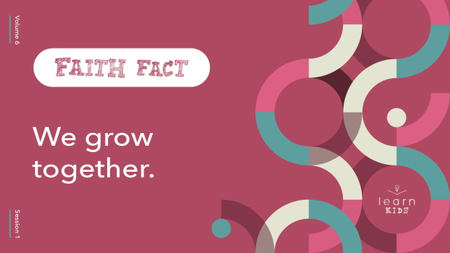

A fun way to remember this Faith Fact would be to “grow up” while we say it. Let’s all squat down as low as possible and shoot up in the air when we say the Faith Fact. Ready? **We grow together**. Let’s try that together a couple times. Say it with me. **We grow together**.

• *Make sure everyone gets down on the floor as low as possible and shoots up in the air while they say the Faith Fact*.

**Game**

**Roots, Trunk, and Branches**

Growing together doesn’t mean we’re all supposed to turn out exactly the same as apples in an apple tree. For example, have you noticed that you’re better at certain things than your friends? *(Group response)* Now raise your hand if there are some things your friends are better at than you are. *(Group response)*. Why do you think God made us that way? *(Allow responses.)*

God gave each of us different talents and abilities to be used for Him. If we were all good at the same things, life would be really boring. A lot of things would never get done because no one would know how to do them. We need all different types of people with different abilities to grow healthy together. That’s what our Faith Fact is about. Say it with me. **We grow together**.

Let’s think about the apple tree again. There are many different parts that make up a tree. We’ll be using three of the main parts in our game today: roots, trunk, and branches. Now, let’s add some actions to those words.

• *Demonstrate the following actions for the group*.

For the roots, bend over and touch your fingertips to the floor. For the trunk, hug yourself tightly around your waist. For the branches, put your arms up high and wiggle your fingers. Let’s try it.

• *Lead kids in practicing the actions for roots, trunk, and branches*.

I think we’re ready to play. Find a partner and stand with your backs to each other. For each round, I’ll count down from three. When I say, “Go,” turn around quickly and do one of the three actions we just practiced. If you and your partner match actions, then you’re both out. If you do a different action from your partner, you’re both still in the game. We’ll play until we get down to the winning team.

• *Keep playing rounds until you get down to the winning team*.

• *If you have time, play again. Allow kids to choose new partners*.

Wasn’t that fun? Can you imagine if trees only had roots or only a trunk or only branches? Trees need all those parts to be healthy and to grow. As God’s family, we need each other to grow healthy and strong.

**Worship**

One of the things I love doing together with you is worshipping. You can worship alone, but it’s not the same as worshipping with a group of people who all love Jesus. Are you ready to sing and worship with me? *(Group response)*

• *Lead the kids in singing one or two praise songs. See suggestions at the beginning of the session*.

**Bible Lesson**

Do you notice a difference between worshipping God together and on your own? *(Group response)* It’s still a great idea to worship God by yourself all week long, but there’s something special about coming together in worship. God loves it when we open up our Bible and spend time in His Word together. That’s what we’re about to do, but first let’s pray and ask God to show us what He wants us to learn today from His Word.

**Prayer**

|  |
| --- |
| *Dear God, thank You for allowing us to meet together with other Christians and learn more about You. Amen.* |

**Video Intro**

Before we look at God’s Word, let’s watch this video.

• *Play* ***Bible Lesson Video***.

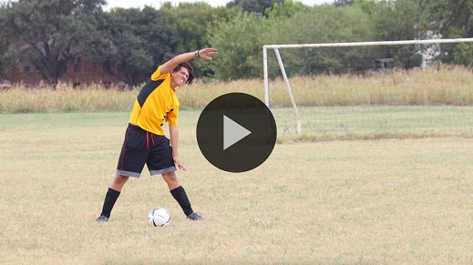

**Bible Story**

**Believers Grow Together**

That video was such a fun lead-in to our Bible time today. After Jesus went back to heaven, the disciples told a lot of people about Him. As more people became Christians, the Early Church grew. These believers knew the importance of growing together. You’ll see what I’m talking about in today’s Bible reading. Grab your Bible or pull up a Bible app on your device. Turn to [Acts 2:42–47](https://ref.ly/logosref/Bible.Ac2.42-47).

• *Read the Bible story aloud to the group*.

• *In order to keep Large Group time moving along, we don’t recommend having the kids read*.

• *Optional: Remind the kids to mark this place with their Bible Bookmark, so they can read it on their own at home*.

**Teaching Time**

|  |
| --- |
| ***You Will Need***   * ***Teaching Point Slides 1–3*** * *Potted plant with good roots (You must be able to pull the plant out of the pot and show the kids the roots.)* * *Plastic glove* * *Disposable tablecloth* * *10–12 large blocks (enough to build a large tower quickly)* * *Small table* * *Basketball*   ***Getting Ready***   * *Set up the table and items you’ll use during Teaching Time.* * *Cover the table with the tablecloth.* * *Put on the plastic gloves as you handle the potted plant.* |

We can learn a lot from the Early Church in the Book of Acts. They didn’t just meet one or two days a week. They did many things together. They ate together, lived together, prayed together, and took care of each other. What is one thing you just heard that we already do together here at church? *(Allow responses.)* Those things definitely help us grow together.

That reminds me of our Faith Fact. **We grow together.** Let’s look at how we can be more like the Early Church and help each other grow.

**1. Believers commit to grow together**.

• *Show the* ***Teaching Point 1 Slide***.

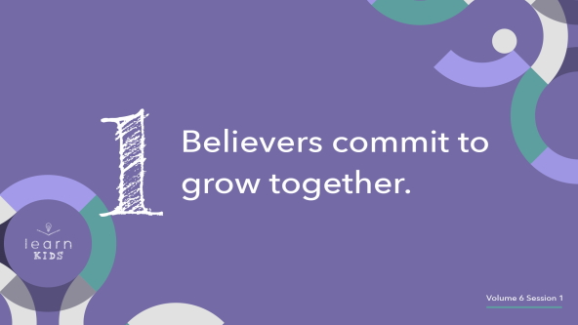

We won’t grow together without being intentional and committing to help each other. By nature, we’re selfish and want what’s best for ourself. When we’re part of God’s family, we should put others first. The best way to grow is to grow together. Let’s take a look at an example of this idea in nature.

• *Hold up a potted plant*.

How does this plant grow? *(Allow responses.)* Yes, it needs water, sunlight, and care. It also has to have its roots in good soil to grow.

• *Pull the plant out of the pot and remove enough dirt with your hands so the kids can see the roots*.

A plant must be rooted to grow. Most plants have more than one main root. They have multiple roots. Why is that? *(Allow responses.)* The roots keep the plant we see above ground healthy and growing. A healthy plant should have roots that grow deeper and stronger together.

When a storm or enemy of the plant comes along, the roots keep the plant strong and alive. The roots must work together or the plant will not survive. As believers, we must commit to grow together just like the roots of a plant. Then, we’ll all be stronger because we have each other.

**2. Believers encourage each other**.

• *Show the* ***Teaching Point 2 Slide***.

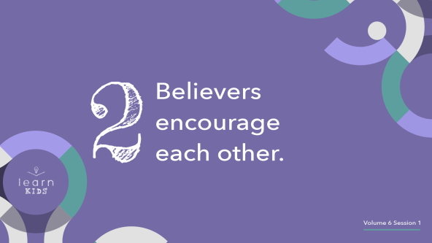

Did you know we have one of the most powerful weapons or tools at our disposal all day every day? Can anyone guess what I’m talking about? *(Allow responses.)* Those are good ideas. I’m talking about our tongue and the words we speak. We have the power to build up others with encouraging words or to tear them down using mean words. As Christians, we should use our words to encourage others and speak good things to them and about them.

• *Build a tower with blocks while you talk*.

Words have the power to build others up or tear them down. [Proverbs 18:21](https://ref.ly/logosref/Bible.Pr18.21) reminds us that our tongue has power to bring death or life. We’ll reap the consequences of what we say: good or bad. Have you ever heard the saying, “Sticks and stones may break my bones, but words will never hurt me”? That saying couldn’t be more wrong. Words do have the power to hurt others emotionally and spiritually, just as sticks and stones have the power to hurt someone physically.

• *Knock down the tower you just built. Then, start to build it again*.

Building up each other is what we should be doing, not hurting others with our words. Let’s choose to encourage each other with what we say.

**3. Believers challenge each other**.

• *Show the* ***Teaching Point 3 Slide***.

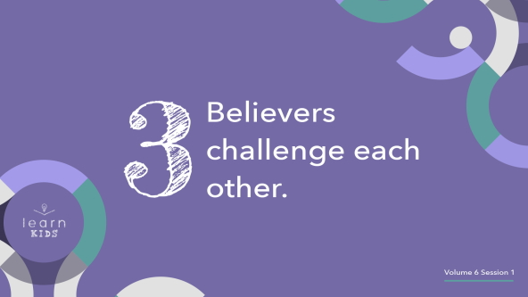

When most people think of challenging someone, they think about a competition.

• *Bounce the basketball while you talk and then pretend to shoot it*.

For example, I could challenge someone to see who can make the most baskets. That’s not exactly what we’re talking about here. Challenging each other doesn’t mean that we make it a competition between us and other believers. Our Faith Fact tells us that we should grow together, not against each other.

One of the ways we grow together is by helping each other become better. When we get together with other Christians who have different talents and then we all use our talents to make something better, that’s growing together.

We also need people in our life who care about us enough to challenge us. For example, we might allow a friend to call us out when they see us making bad choices. Hopefully, our Christian friends want us to do the same thing for them. When we grow together, we want what’s best for each other.

Remember, it’s not a competition. You should never feel bad about what you can do well compared to someone else. God has given each of us the strengths and giftings we need to accomplish what He has called us to do. When a runner is running a race, how do they win? *(Allow responses.)* They win by working hard and keeping their focus on the track ahead of them. Don’t get distracted and fall because you’re too busy looking at what other people can do. Keep your focus on God and what He has called you to do.

**Prayer and Response**

*Consider playing a worship song softly in the background while kids pray*.

Since today we’re talking about growing together, I think it would be appropriate for us to do what the Early Church did together. Let’s end our time by praying for each other.

Let’s gather in groups of two or three. The Faith Verse tells us that God is with us when we gather like that. Then, share at least one thing you’d like everyone to pray for. When you’re ready, have everyone in your group pray for someone else’s need. Then, we’ll close in prayer together.

• *Help kids get into groups and make sure no kids are sitting alone*.

• *If needed, help kids get started and offer examples of things they can pray for*.

• *Make sure all the kids are quiet and respectful while the other groups finish up their prayer time*.

**Prayer**

• *Optional: Have the kids repeat phrases of the prayer after you*.

|  |
| --- |
| Dear God, thank You for giving us a church full of people who love God and love each other. Teach us to grow together and not try to do life on our own. We love You. Amen. |

**Faith Verse**

Our Faith Verse teaches us the importance of growing together. It tells us that even when we gather only with one or two other people, God is there. Let’s learn our Faith Verse and do the actions together.

• *Play* ***Faith Verse Video***.

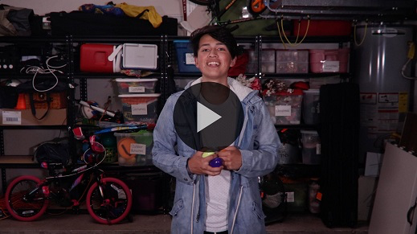

[Matthew 18:20](https://ref.ly/logosref/Bible.Mt18.20)

“For where two or three gather together as my followers, I am there among them.”

That verse doesn’t tell us what we have to do together specifically. It simply reminds us of the importance and power behind being together. That’s why it’s so important that we come to church. We need each other to continue growing in our faith.

**Faith Fact**

Before we go to our small groups, let’s review our Faith Fact again.

• *Show the* ***Faith Fact Slide***.



Say it with me. **We grow together**. If you’re thankful you get to grow with our church family, make some noise! *(Group response)* I’m thankful for all of you.

• *Dismiss kids to Small Group time or to go home if your group time ends here*.

**Small Group**

**30 Minutes**

*This section can be done in conjunction with the large group or on its own if you do small groups with your kids. During Small Group time, the goal is to connect the kids with the Word of God and to each other. All activities are led by the small group leader.*

**Group Connection**

**Towers of Encouragement**

|  |
| --- |
| ***You Will Need***   * *Large building blocks, forty blocks per group* * ***Countdown60 Video****–60 seconds*   *No prep needed for this activity.* |

We learned that one of the ways we grow together is by encouraging each other. Remember how important and powerful your words are? *(Group response)* God’s Word tells us that our tongue is so powerful that it can bring death or life. Let’s use that power to come up with encouraging words we can say to each other to build up each other.

Let’s divide into two teams. Each team will get some blocks. You’ll attempt to build a taller tower than the other team, but there’s a catch. You can only put a block on the tower after you say something encouraging to someone else. When it’s your turn, you can encourage everyone in your group or only one person. That’s up to you.

• *Consider demonstrating this activity by saying something positive to each person in the group as you build a tower*.

You will only have one minute to build your towers of encouragement, so let’s start building.

• *Start the* ***Countdown60 Video***.

• *Listen to the teams to ensure they are coming up with words of encouragement before they stack blocks on their towers*.

• *At the end of the time, the team with the taller tower wins*.

Those were some tall towers! More importantly, you did an amazing job of growing together with words of encouragement to build up each other.

• *Play again if you have time*.

**Learn about It**

|  |
| --- |
| ***You Will Need***   * *Bibles for kids in your group to share*   *No prep needed for this activity.* |

**Scripture Search:** [**Proverbs 27:17**](https://ref.ly/logosref/Bible.Pr27.17)**;** [**1 Corinthians 12:21–26**](https://ref.ly/logosref/Bible.1Co12.21-26)**;** [**Romans 12:9–10**](https://ref.ly/logosref/Bible.Ro12.9-10)**;** [**Hebrews 10:24–25**](https://ref.ly/logosref/Bible.Heb10.24-25)

Let’s see what else God’s Word has to say about the importance of growing together. As we find and read each of these verses, let’s consider: What does this Scripture mean for our life today?

* *Give each kid a Bible and search for one or more of the Scriptures as a group together (as time allows). When everyone has found the Scripture, have one of the kids read it. Then, answer the questions about it*.

• *Pair kids who need additional help with older kids or start simple and look up the session’s Bible story Scripture:* [*Acts 2:42–47*](https://ref.ly/logosref/Bible.Ac2.42-47)*. Kids will get better finding Scriptures the more they practice*.

• *Optional: Make this a competition to see who can find the Scripture first*.

**Bible Reading Tip**

It can be fun to switch things up every once and awhile. If you normally read the Bible on your own, try reading it with someone else this week. You could read your Bible with a parent, sibling, friend, or other family member. If you normally read your Bible with your family, share your Bible time with someone else.

**Challenge**

Take this Bible reading tip to the next level with this challenge. Find someone new to read the Bible with this week. Switch off who gets to choose what you’ll be reading each day. This challenge will make you think more about what you’re reading and what it means. It might even open your eyes to a part of the Bible you haven’t read yet.

**Faith Fact**

As you read God’s Word with others, remember our Faith Fact. **We grow together**. Let’s say that together one more time. **We grow together**.

**Group Discussion**

*Feel free to use all or just a few questions as a jumping-off place for good discussion. Questions marked with * are designed for more conversation. Adjust the questions based on the age or maturity of your group. Typically, older kids will be able to dive a little deeper than younger ones*.

**Questions**

• *If small group activities are not immediately following large group time, you may want to read the Bible story passage before this discussion*.

* In [Acts 2](https://ref.ly/logosref/Bible.Ac2), early Christians devoted themselves to teaching, fellowship, eating together, and prayer. How is our church like this?

What happened while the believers were doing everything together? (See [Acts 2:44–47](https://ref.ly/logosref/Bible.Ac2.44-47).)

How do your Christian friends help you grow?

How do your parents help you grow?

* What are ways that you can help others grow?

What is one encouraging thing someone has said to you?

* What is something encouraging you could say to someone or do for them this week?

* Do your friends challenge you? How?

* How can you challenge your family or friends to be better in a kind way?

**Prayer Requests**

*Finish group discussion by sharing prayer requests and praise reports. Keep track of your small group’s prayer requests and review them each time you meet*.

**Prayer**

*Have kids pray for each other’s prayer requests*.

**Faith Verse Review**

Our Faith Verse reminds us that God shows up when we get together with other believers. It doesn’t even have to be a large group. God loves it when even just a couple people grow together. Let’s practice the actions.

• *Show* ***Faith Verse Video***.



[Matthew 18:20](https://ref.ly/logosref/Bible.Mt18.20) (NLT)

“For where two or three gather together as my followers, I am there among them.”

Say the Faith Verse with me again and do your best to remember it. You’ll need to know it for the activity we’ll do next.

• *Say the verse as a group a couple of times*.

**Faith Verse Fun**

**Get Creative!**

For our activity, you’ll get into groups of two or three just like the Faith Verse says. I want to see which group can work together to be the most creative. You’ll have a few minutes to come up with a creative way to present the Faith Verse to the rest of the group. For example, you might want to act it out or say it in a fun way. Are you ready to take on this challenge? *(Group response)*

• *Have the kids form groups of two or three and allow them to practice*.

• *Give each group time to present to the rest of the group*.

• *Optional: Decide which team worked together the best and came up with the most creative way to present the verse*.

I love seeing the creativity that comes out when you grow together. You all did an amazing job presenting the verse creatively and working together as a team.

**Activity Page**

**Help Others Grow!**

|  |
| --- |
| ***You Will Need***   * ***Small Group Activity Page****, one per kid* * *Pencils, one per kid* * *Optional: Markers or crayons*   ***Getting Ready***   * *Print copies of the* ***Small Group Activity Page****, one per kid.* |

Encouraging words help others grow just like water and sunlight help plants grow.

• *Give each kid a copy of the* ***Small Group Activity Page*** *and a pencil*.

In each leaf is someone you can encourage. Come up with the encouraging words you can say to that person. Then, write the words on each of the leaves.

• *Help kids come up with ideas if needed*.

Throughout the week, don’t just keep this activity on paper. Use some of those words to encourage other people in your life. As you encourage others and help them grow, color in the leaves.

• *Optional: Pass out markers to color the pot but not the leaves*.

**Dismissal**

Thanks for joining me today. I hope you learned how important coming to church and growing together with other believers really is. I need you, and you need me. God tells us that in His Word. Let’s continue helping others grow all week. Let’s close by praying.

**Prayer**

|  |
| --- |
| *Dear God, help us to remember how important we are to each other. Remind us that we need You, and we need each other to grow together. Amen.* |

**Faith Fact Recap**

• *Show the* ***Faith Fact Slide***.



Before we leave, let’s say our Faith Fact together one more time. But let’s make it the loudest one yet. Ready? **We grow together.** I can’t wait to grow together with you again next time as we continue to answer the question, “Why is my church family important?” See you soon!

• *Send home the* ***Small Group Activity Page***.

• *Remind parents that there are* ***Family Devotions*** *available on the app to do with their kid*.

• *Tell everyone the date and time for the next session*.